***CHENGDU AMERICAN CENTER FOR STUDY ABROAD***

***Faculty Pre-Departure Guide – Summer 2016***

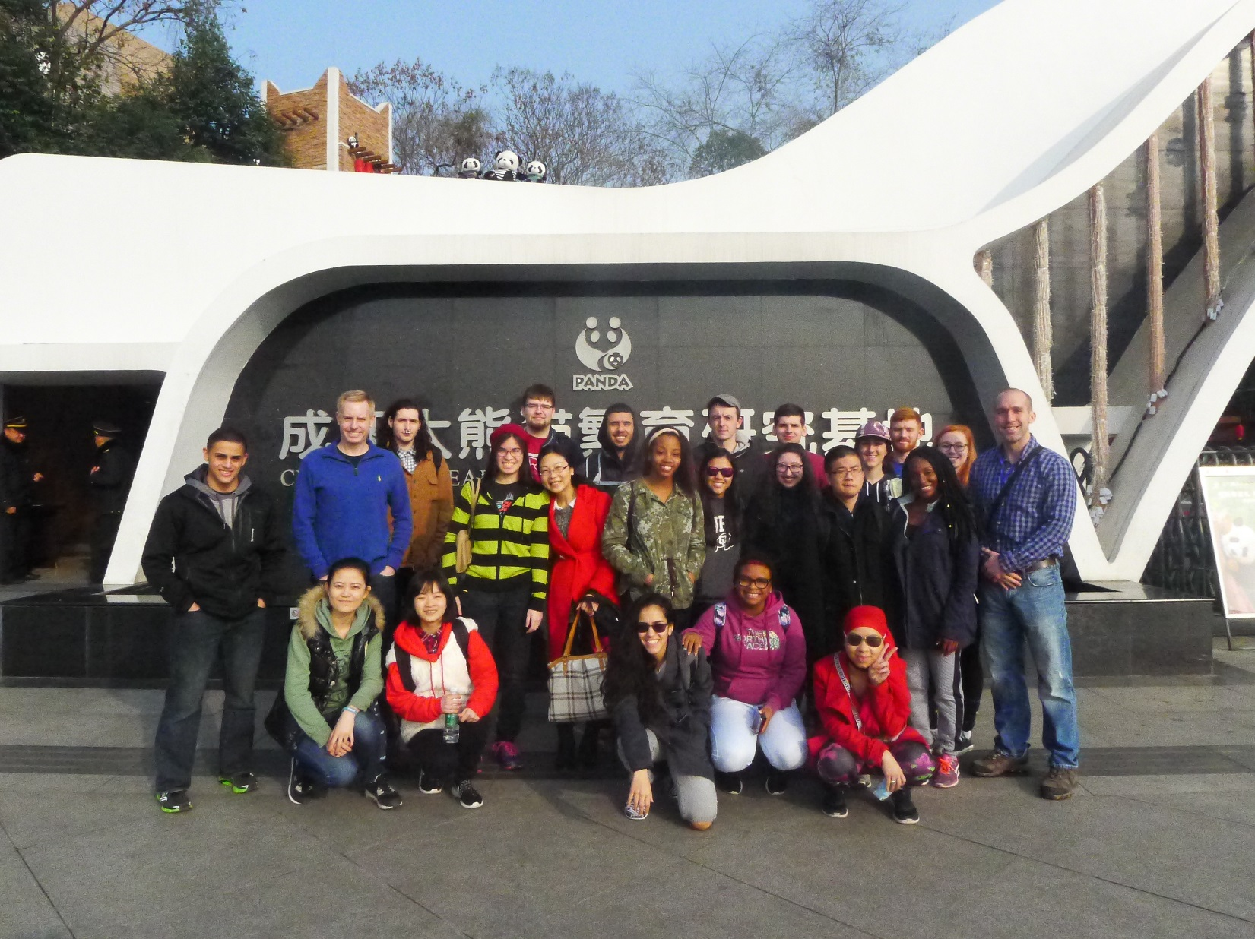

**Index**

1. Contacts
2. Chengdu American Center Policies
3. Passport and Visa
   1. Applying for a Chinese Visa
4. Academics
5. Flight Arrangements
6. Important Documents
7. Safety, Health, and HTH Health Insurance
   1. Safety
   2. Health
   3. Air Pollution
8. Finances
   1. Accessing Money while Abroad
9. Cell Phones and Internet
10. Things You’ll Need (Packing List)
11. In Chengdu
    1. Arrival
    2. Academic Calendar
    3. Important Notes on Academic Calendar and On-site Orientation
    4. Housing and Meals
    5. Laws and Regulations
    6. Culture Shock
    7. Outside of the Classroom
    8. Travel and Transportation
12. Returning Home
13. Some Things to Think About
14. Useful Resource
15. **Contacts**

**New York Team**

g-MEO, New York Office

260 Madison Ave, 8046

New York, New York 10016

Tel: +1(646) 216-2186

24/7 Emergency Tel: +1 (718) 496-3450

**Sherry Sun**,

**Chief Operating Officer and President of Greater China**

**E-mail:** [sherry.sun@g-meo.com](mailto:Dina.Iskaros@g-MEO.com)

**Cell**: +1 (646) 216-2189

**Wen Wang**, Manager, Student & Business Affairs

E-mail:[W](mailto:W)en.Wang@g-MEO.com

**Stella Shi**, Manager, Marketing and Recruitment

E-mail: [Stella.Shi@g-meo.com](mailto:Stella.Shi@g-meo.com)

**Amanda Akyol**, Manager, Admissions and Enrollment

Email: [Amanda.Akyol@g-meo.com](mailto:Amanda.Akyol@g-meo.com)

**Estella Fu,** Enrollment Management Associate

E-mail**:** [Estella.Fu@g-MEO.com](mailto:Estella.Fu@g-MEO.com)

**Kejia Hu**, Marketing and Recruitment Associate

Email: Kejia.Hu@g-meo.com

**China Team**

Chengdu American Center for Study Abroad

Huaxi Campus, Sichuan University,

No. 17, Section 3, Renmin South Road, Chengdu, 610041, P.R. China

Tel: +86 28-85502761

China 24/7 Emergency Tel: +86 158 8214 0846

**Ms. Jingyu Wang,** Director

Chengdu American Center for Study Abroad, g-MEO

E-mail: Jingyu[.Wang@g-MEO.com](mailto:.Wang@g-MEO.com)

Mobile: +86 186-2838-8329

**Dr. Andrew Bosworth**, Adjunct Professor & Senior Counselor

E-mail: [Andrew.Bosworth@g-MEO.com](mailto:Andrew.Bosworth@g-MEO.com)

Mobile: +86 183 8020 8420

**Ms. Sara Luo,** Office Manager

E-mail: [Sara.Luo@g-MEO.com](mailto:Sara.Luo@g-MEO.com)

Mobile: +86 158 8214 0846

Miss Mandy Li, Student Life Coordinator

Email: [Mandy.li@g-meo.com](mailto:Mandy.li@g-meo.com)

Mobile: +86 135 5117 1569

1. **Chengdu American Center Policies**

**Equal Opportunity/Affirmative Action Policy Statement**

Global Maximum Educational Opportunities, Inc. (g-MEO) provides equal employment opportunity as well as equity of conditions of employment to all its academic and non-academic employees and applicants for employment without regard to sex, race, ethnic origin, religion, age, creed, sexual orientation, or marital status. Recruitment, hiring, promotion, training and the designation of salaries and benefits and all other personnel matters are to be implemented and carried out in such a manner as to insure equity for all qualified persons without preference being given to anyone on the basis of sex, race, ethnic origin, religion, age, creed, sexual orientation, or marital status.

**g-MEO Non-Discrimination Policy**

Global Maximum Educational Opportunities, Inc. (g-MEO) is committed to equal academic opportunity to all students attending any of g-MEO’s Study Abroad Programs in China. It is also committed to maintaining an academic and work environment for students, faculty and staff which is conducive to the achievement of educational and career goals on the basis of ability and performance, and which is free of discrimination on the basis of race, sex, color, age, national origin, handicap, sexual orientation, religion or marital status.

Since discriminatory behavior may seriously undermine the atmosphere of trust essential to the academic and work environment of g-MEO’s Study Abroad Programs in China, anyone who violates this policy may be subject to disciplinary action, including suspension or termination.

1. **Passport & Visa**

Please make sure you have a valid passport with at least 6 months validity remaining from program end date. It can take up to 8 weeks for a passport application to be processed by the US Department of State, so make sure you obtain a passport as soon as possible to avoid extra fees for expediting. If you do not have a passport or if it is expired, you can obtain a passport application through your local post office. You will need to bring your expired passport, a completed DS-11 form, an accepted form of photo ID, proof of your US citizenship (your original birth certificate is fine), one 2x2” passport photo, and a check or money order. Remember, the person applying must be present. No cash or credit cards are accepted.

Check the US Department of State website for more information on passports:

<http://travel.state.gov/passport/forms/ds11/ds11_842.html>

If you are not a US resident, please consult the appropriate country authority in relation to passport photo size and requirements.

**Applying for a Chinese Visa**

As you will be in China for less than 6 months **you will be applying for a Tourist Visa (l Visa) . g-MEO is dedicated to ensure all visa processing. Please find** [HERE](http://www.china-embassy.org/eng/zmzlglj/t84229.htm) **which consulate you should be applying for your visa based on your home address. All applications are paper-based, no online application will not be accepted. Please find following a list of items you will need to present at the consulate.**

**- Passport valid for at least 6 six month from July and two blank pages (if you don't have a passport, you will please need to apply right away, it can take 4 to 6 weeks to process)**

**- Completed and signed visa application form, please download** [HERE](http://www.china-embassy.org/chn/lszj/bgxz/P020130830121570742708.pdf)

**- Itinerary**

**- Two recent passport sized photos**

**- $140 visa application fee (check, money order, visa or master card)**

**Please find more information about visa** [HERE](http://www.china-embassy.org/eng/visas/hrsq/)

**We HIGHLY recommend your to work with two visa agent in New York and Chicago area, please find below their contact information. Please contact me should you need to process visa in other consulate.**

**New York:**

**LLL International Travel**

**Amy Huang**

**36-36 Main St #2n, Flushing, NY 11354**

**Phone: 718-886-9884**

**Chicago:**

**China visa solutions**

**Shawn**

**Emal: info@chinavisaforyou.com**

**Phone: 630-362-5575**

1. **Academics**

All faculty members should be in communication with the institution that is offering the course they are teaching for more detailed information about the academic aspects. The New York Office will provide you with detailed information on the course you are teaching including a copy of the syllabus as well as the detailed information on the book(s) required for the course. The syllabus of each course is also available online at <http://sapms.gmeochina.com/searchCourse.php?program=2>. Faculty members should review and edit this document in order to meet the requirements of the semester. Please note that students registered in your course have received pre-approval from their home institutions for transfer credit of the course based on the syllabus online. For this reason, the course content indicated in the syllabus must remain the same. However, please provide the New York Office with any changes you wish to make to the textbook(s).

Each faculty member is responsible for bringing two copies of the required textbook(s) to Chengdu. This will be arranged through the New York Office with the partner institution offering the course. One copy will be for your use and the other will be placed in the Chengdu Center library.

Each classroom is supplied with a whiteboard, markers, erasers, a projector, and a projector screen.

1. **Flight Arrangements**

Please ensure that your arrival date in Chengdu is on **Friday, June 10th, 2016**. Faculty departure date is scheduled at noon of **Saturday, July 9th, 2016**.

You can either seek the assistance of a travel agency to book a flight or use search engines such as Kayak, Statravel.com or Studentuniverse.com, etc. Please, be sure that your final destination is Chengdu Shuangliu International Airport (CTU).

g-MEO, New York Office can recommend LLL International Travel Agency. If you will use their service, please do inform them that you were referred by g-MEO’s New York Office. g-MEO cannot guarantee their rates so please do your due diligence and ensure you are receiving the best rates prior to booking your flight. LLC International Travel Agency can be contacted as follows:

Postal Address: 36-36 Main Street #2N, Flushing, NY 11354  
Telephone #: +1(718) 886-9884 Amy Huang

Fax: +1(718) 886-0459

Website: <http://www.llltravel.com/>

Once you have booked your flight, please e-mail Miss Sara Luo at [sara.luo@g-meo.com.com](mailto:sara.luo@g-meo.com.com), Office Manager at Chengdu American Center and Ms. Wen Wang [Wen.Wang@g-MEO.com](mailto:Wen.Wang@g-MEO.com), Program Coordinator, with your flight information (see below). This information will enable our China staff to schedule your airport pick up upon arrival in Chengdu. In the event that your flight is delayed or you miss a connecting flight, it is imperative that you contact the 24/7 emergency number either in China or New York to inform g-MEO of your delay.

Information to Provide:

* + 1. All legs of flights (i.e. New York -->Beijing; Beijing-->Chengdu)
    2. Departure and Arrival Times
    3. Airlines
    4. Flight Numbers
    5. Departure/Arrival Cities
    6. Contact Information during the Trip (if applicable)

*Note: we recommend faculty choose the direct flight from San Francisco to Chengdu since this will be more convenient and will help you avoid some of the chaos at the Beijing or Shanghai airports.*

1. **Important Documents**

You will need at least two copies of all important documents. Your passport, visa, plane ticket, credit cards, ATM cards, health insurance card and any other important documents should be copied prior to your departure to China. You should write down important phone numbers (such as your emergency contacts, bank, Credit Card Company, etc.) and make two copies of them also. Leave one set of your key documents with a family member or trusted friend in the U.S. and keep the other set with you, separate from the originals.

During the on-site orientation at the Chengdu American Center, a copy of your passport information page and the Chinese visa page (with the immigration stamp) will be made. These copies will be given to Ms. Sara Luo, Office Manager of the Chengdu American Center for Study Abroad in China to be placed in your file.

*\*All faculty members are required to email g-MEO Staff in NYC at <wen.wang@g-MEO.com) a soft copy of their passport sized photo prior to their departure for China. This will allow us to produce your cafeteria and ID cards.*

1. **Safety, Health, and HTH Health Insurance**

**Safety**

g-MEO’s top priority is the health and safety of all our students and faculty. It is extremely important for all faculty to keep lines of communication open with both your family, and the g-MEO staff. Highly qualified g- MEO staff are available for faculty and students 24/7. Our staff in China all speak fluent English and Mandarin and can easily converse with faculty, students and locals. Our New York City Office also has a 24/7 hotline. The 24/7 emergency number in the **United States is +1 (718) 496-3450**. The 24/7 Emergency number in **China is +86 158-8214-0846**. g-MEO’s China and New York City Headquarters are there to help in case of any emergency. We are in constant communication with each other and with home universities.

Faculty members sixty-five years or younger are eligible for coverage from g-MEO, through **HTH Worldwide Insurance (HTH.)** HTHprovidesfaculty members with a rider on their health insurance policy that provides them with “political uprising and Natural Disaster evacuation” insurance. This means that HTH Worldwide Insurance Company is responsible for evacuating our students and faculty members in the rare case that evacuation is required.

In order for g-MEO to ensure your safety, you will need to provide us with your contact information at all times. g-MEO will require that you provide the g-MEO personnel in China with your China cell phone number. In addition, if you ever plan on being out of your apartment overnight for travel, we ask that you provide us with notification of this.

All faculty are encouraged to enroll in the U.S. State Department’s Smart Traveler Enrollment Program (STEP). STEP allows the Department of State to better assist travelers in the event of an emergency. Enroll here: <https://step.state.gov/step/>.

**Health**

We encourage all faculty members to make an appointment with their family physicians for a full physical check-up prior to leaving for China. Please notify them that you will be in China for up to 6 months and ask what immunizations they suggest you receive. This will be different for each individual based on their medical history and immunization records.

Once you are enrolled in HTH Worldwide insurance, you will receive login information to the website exclusively for participants. Through this website, you can print your **HTH Insurance card**, determine the availability of certain prescriptions you are currently taking, information on doctors and hospitals you can visit while in China, etc.

If you are currently taking any prescription drugs, check the HTH Worldwide Insurance Company website to see if this drug is legal in China. If it is legal, you will need to determine if it is available under the same name as in the US. If the prescription drug is legal in China, the ideal situation is to obtain enough of the prescription for the duration of your stay in China.

When traveling with prescriptions, the prescription must be packaged in its original bottle and must be accompanied by an official letter from your physician authorizing you to travel with the prescription and indicating it was prescribed by him/her for personal use. **Medication should be packed in your carry-on bag NOT your checked luggage.**

In the event you cannot travel with adequate supplies of the prescription, please ensure that the prescription is available in China and that your physician has approved refilling your prescription in China specifically. If this is the case, please inform g-MEO staff prior to departure.

**Air Pollution**

Air quality is a concern in major Chinese cities, even though the quality of air can differ greatly between cities or between urban and rural areas. At g-MEO, your health and safety is our primary concern, and both our New York and Chengdu offices work closely to keep abreast with both local and regional issues. The US Environmental Protection Agency Air Quality Index (AQI) provides guidance for when the PM 2.5 count reaches levels of concern (<http://airnow.gov/index.cfm?action=aqibasics.aqi>). During this time, they may recommend reducing or avoiding outdoor physical activities. Additionally, PM 2.5-filtering masks can be easily obtained in Chengdu, and throughout China. Moreover, we strongly recommend that faculty with asthma or sensitivity to air-born particulates consult with his/her physician. Our onsite staff monitors the AQI and updates faculty members and students as necessary. We might also make any necessary adjustments to our excursions/schedule, taking the AQI into account.

For additional information:

The Chinese Ministry of Environmental Protection provides its own air quality data for cities throughout China. You can view the information at <http://english.mep.gov.cn>.

Additionally, the U.S. Consulate in Chengdu provides air quality data, which is available to all US citizens. You can find this data at: <http://chengdu.usembassy-china.org.cn/air-quality-monitor4.html>

If you plan to travel to other major cities such as Beijing or Shanghai, you can refer to:

*U.S. Embassy Beijing air quality data: <http://beijing.usembassy-china.org.cn/070109air.html>

*U.S. Consulate in Shanghai air quality data: <http://shanghai.usembassy-china.org.cn/airmonitor.html>

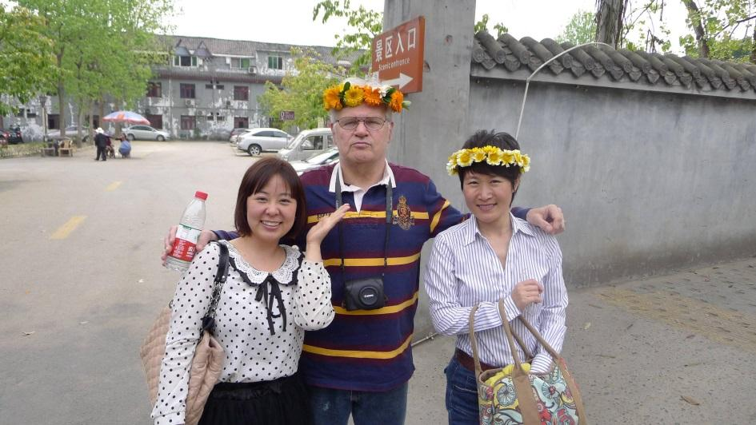

Dr. Orrick (Norwich University) with g-MEO China staff members Jingyu Wang and Karen Li

1. **Finances**

The amount of money you will spend depends on your eating habits and lifestyle. A regular Chinese meal in Chengdu costs $3-5. A nice dinner might cost $10-20 per person. A subway ride costs 35 cents while a taxi ride for 10 km costs $6.

Please see the Faculty Budget below for estimated expense amounts for your one-semester study program in China. Keep in mind that exchange rates change daily. You may also reference the following website for more detailed cost of living information:

<http://www.numbeo.com/cost-of-living/city_result.jsp?country=China&city=Chengdu>

|  |  |
| --- | --- |
| **Expense** | **Amount** |
| **Living Expenses** | $600 to $800 (per month) |
| **Airfare** | $1200 to $1800 for roundtrip |
| **New Passport** | $110 to $135 |
| **Visa** | $140 |
| **Local Transportation** | $8 for Transit Card (includes $3 deposit + $5 balance) |
| **Cell Phone** | $60 to $180 for device, $5/month for service |

*\*All estimates are in US dollars (USD) and subject to change. The amount of money you will require while in China will depend on your eating and life style habits and is subject to fluctuation depending on the current exchange rate. For example, your spending will be much higher if you choose to eat at Western restaurants on a daily basis.*

**Personal Expenses:**

* Toiletries: $80
* Souvenirs: $10 to $100 per item
* Entertainment: Movie tickets are about $10.
* Local Transportation: about $80 per month for local weekend transportation (the subway depends on distance and is about 40-80 cents per ride.) The g-MEO staff will provide you with a transportation card during orientation. You will pay a $4 (25 RMB) deposit plus $4 (25 RMB) initial balance for a total of $8 (50 RMB). Taxi is about $4 per ride inside the city. You may also purchase a second-hand bike for roughly $30 -$40 for use around the city.

**Accessing Money While Abroad**

Faculty should bring about $1000 (6125 RMB) in cash for your month in Chengdu. You can exchange US dollars at the airport upon arrival as the rate tends to be better in China than the US. It is extremely important to set a budget and stick to it throughout your stay. You don’t want to find yourself short of money with time still left in your stay. It’s important to familiarize yourself with the local currency and exchange rates and take advantage of discounts while visiting museums and other attractions. The current official exchange rate is 1.00 Chinese Yuan Renminbi to US $0.16, or approximately 6.20 Yuan to the US Dollar. The symbol for the Yuan is ¥, and the abbreviation for Renminbi is RMB. However the exchange rate changes daily so be sure to check online for up to date rates.

ATMs are readily available in China and abroad so you can continue to use your current U.S. bank account to withdraw money. Prior to your departure, you must speak with your bank representative about matters concerning your account such as withdrawal fees, daily ATM withdrawal limits, how your cards will function overseas, setting up online accounts, etc. Some banks will waive such charges so if you find them to be exorbitant, you may wish to consider opening an account with a bank that waives these charges. Please ensure that someone you trust has access to your US bank account so that if needed, they can deposit additional funds in your account while you are abroad.

If you would like, you can also open a Chinese bank account. More information on that will be provided during on-site orientation.

*\*Once you have booked your airline ticket, please call your Credit Card Company and bank to inform them that you will be teaching abroad for the semester. They will need your dates of departure and return to the US. Also inform them if you’ll be traveling to other countries prior to your return to the U.S.*

1. **Cell Phones & Internet**

You can bring your iPhones/smart phones with you to Chengdu. If your phone is unlocked, you can use it regularly in China. If you have a locked smart phone, you can only use it in areas with Wi-Fi. For day to day calls, it is best to purchase a simple cell phone for about $60 USD once you arrive in Chengdu. If you buy a local phone, you will also need to buy a SIM card. There are various calling plans that allow you to receive calls for free, to make local calls at no more than 10 US cents per minute, and to send a text message at no more than 2 US cents per text. Cell phones purchased abroad might not work in the United States. **Keep in mind:** onthe 1st-3rd of every month, the provider will deduct the monthly plan payment from your balance. Therefore, by the end of the month, you must have a balance more than the price of your monthly plan to keep your phone working.

*Note that websites such as Facebook & YouTube cannot be accessed in China without VPN (virtual private network). Please check with your institution if you can obtain a VPN for free. Please do a search online to check which websites may be accessed before arriving to China.*

Keeping in touch with family is critically important for you and for them. The best way to do so is through the use of Skype. Keep in mind that there is roughly a 12 hour time difference between China and Eastern Standard Time. Getting in touch with family will take some planning. You can download apps like WhatsApp and WeChat (a Chinese version of WhatsApp that is widely in use in China, download link: <http://www.wechat.com/en/download.html>) to communicate daily with your family and friends in the U.S.

*Tip: Once you arrive, remember to call home and let your family know you’re safe. They’ll be worried about you!*

**Suggested Phone Apps to download PRIOR to arrival in China:**

• Pleco Chinese-English Dictionary

• Air Quality China

• WeChat

• Skype

• VPN (any type – both for computer and phone)

1. **Packing List**

Please remember to only pack what you can carry and to monitor the weight of your luggage to avoid extra airline fees. Make sure to check your chosen airline’s website for specific luggage weight requirements. Don’t forget to leave room for souvenirs on your return trip! You are advised to research the weather for the semester you will be spending in China, to give you a better idea of what to pack.

The most important item you will need to take with you is a list of names, phone numbers, postal and email addresses of home campus personnel, g-MEO personnel, g-MEO 24/7 emergency lines both in the US and in China, family and other persons that you might need to contact during your time in China. Keep this list in a safe place and do not pack it in your luggage just in case you need to contact us while in route to China.

**What to Bring:**

* Electric adapter and converter (China’s voltage is 220V)
* **Deodorant**
* Chinese phrase book
* Comfortable walking shoes
* Laptop/tablet
* Camera
* Formal outfit for special occasions
* Basic medicine and first aid: stomach and cold medicine, Band-Aids, etc.
* **Prescription medicine (put this in your carry-on)**
* Toiletries
* Small gifts from home for future local friends

*Tip: If you prefer a particular type of deodorant, it may not exist in China. Make sure you have enough for your stay. Also, large sizes of shoes and clothing are also more difficult to buy in China.*

1. **In Chengdu**

**Upon Arrival**

g-MEO Chengdu American Center for Study Abroad will **arrange your airport pickup on Friday, June 10th, 2016.** Look for a person holding a sign with “**g-MEO**” at the exit for greeting passengers. If you can’t find anyone, call Sara Luo (+86-158-8214-0846). It takes approximately half an hour to drive to the university from the airport but the ride might be slightly shorter or longer depending on the apartment/hotel’s proximity to campus.

*Tip: You’ll be jetlagged, tired and hungry so pack some snacks in case you need them. Be prepared for unfamiliar surroundings and try to stay calm and focused while you settle in!*

**Academic Calendar**

|  |  |  |
| --- | --- | --- |
| **Event** | **From** | **To** |
| Faculty Arrival | 06/10/16 | 06/10/16 |
| Student Arrival | 06/10/16 | 06/10/16 |
| Orientation & Registration | 06/11/16 | 06/11/16 |
| Classes Begin | 06/131/16 | 06/131/16 |
| Classes in Session | 06/13/16 | 06/13/16 |
| Student Departure | 07/09/16 | 07/09/16 |
| Faculty Departure | 07/09/16 | 07/09/16 |
| Grades Due | 07/15/16 | 07/15/16 |

**Important Notes on Academic Calendar and On-site Orientation**

Please note that all faculty members are REQUIRED to attend Orientation on June 11th, 2016. We advise faculty members to arrive early to give themselves an opportunity to adjust to the time zone change and settle in prior to student orientation beginning. All faculty members will also be provided with a briefing on g-MEO’s Chengdu American Center for Study Abroad Program Policies which we ask that you adhere to throughout the duration of the program.

**Accommodations**

To ensure a pleasant stay in Chengdu, **hotel/apartment will be available and paid for by g-MEO from the Faculty Arrival to the Departure date on g-MEO’s program calendar**. If you wish to come earlier or stay longer than those dates, please notify Ms. Sara Luoten days in advanceand extra charges for those days must be paid for by the faculty member. Details about your accommodation option will be sent out by g-MEO New York Office, and covered by the pre-departure orientation.

Please note that faculty members should expect to vacate the room no later than **noon on** **Saturday, July 9th, 2016.**

*For all matters regarding housing, please contact Ms. Sara Luo, g-MEO Chengdu American Center Office Manager at* [*Sara.Luo@g-MEO.com*](mailto:Sara.Luo@g-MEO.com)*.*

We suggest you use our office address on Sichuan University’s campus as a mailing address so that we are able to take care of your important mail even if you move out from your apartment. For your convenience, below is the office address:

中国四川省成都市武侯区人民南路三段17号

四川大学华西校区第四教学楼88号信箱

邮编 610041

手机：028-85502761

**Huaxi Campus Box 88, Sichuan University,**

**No. 17, Section 3, Renmin South Road, Chengdu, Sichuan 610041 People’s Republic of China**

**Phone: 028-85502761**

**Laws and Regulations**

While in China, it is important to remember that the local laws are different from US laws. Although you’re not Chinese, you must abide by Chinese laws. It is important to be aware of the various laws in China and keep informed of current events. Always remember that you are a guest in China, so please behave in a respectful manner and be aware of the rights and wellbeing of others. **It is unlawful for people to participate in demonstrations.** Freedom of speech exists within the walls of the university but even there, be mindful that not everyone around will share your views. During the on-site orientation you will be introduced in more detail to the laws and school regulations that you must observe.

*Tip: Be smart! If something feels wrong, most likely it is wrong.*

**Culture Shock**

While culture shock is often only spoken of in relation to students, it is important for even the well-traveled international scholar to be aware of it. It is also important for faculty members to be aware of culture shock so that they can pick up on the cues and social issues that might arise among students. Culture shock is very common when it comes to studying or traveling abroad. Most students experience it in different ways and at various times throughout their program. Symptoms include but are not limited to missing home, under eating or over eating, depression, withdrawal, worrying excessively and developing obsessive behavior. Student sometimes romanticize their home country and develop overly simplistic stereotypes of unfamiliar people and places around them. Please recommend that students see our on-site g-MEO staff members if you believe that they are not handling culture shock well! Students are usually able to keep such symptoms at bay by developing friendships, eating western foods, or reading a good book. Do not allow students to emotionally withdraw. Please always encourage them to express their feelings to the people who are there to listen. Being trained professionals, the g-MEO staff will be able to determine students’ level of anxiety and determine their need for help.

**Outside of the Classroom**

There are plenty of things to do outside of class! Besides exploring China, volunteer opportunities may be available as well as many on-campus activities. While in China, try to learn as much Mandarin as you can and make friends with local people. Dare yourself to try new foods and discover new interests. While focusing on a new culture it is important to be respectful of others’ political views and social customs. We also recommend you keep a journal, and hold on to ticket stubs, receipts and other such items, as memorabilia.

**Travel and Transportation**

Traveling and seeing all the sights are some of the best things you can do while abroad. If you plan on traveling, we recommend that you travel with at least one other person, and that you notify the g-MEO China staff by filling out a travel form, as well as family members with your travel arrangements. Traveling is a great part of the experience but please remember that safety comes first!

Travel within Chengdu is very convenient as there are multiple bus routes and a subway system. Below is a map of the two subway lines that service Chengdu.

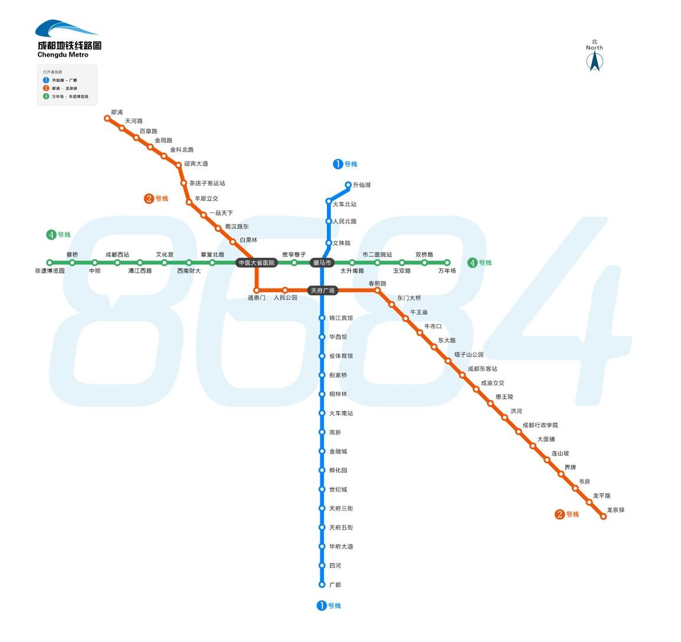

**Returning Home**

Please make sure that you plan to leave Chengdu by **noon on** **Thursday, August 6th, 2015**. You need to make sure you are completely checked out of the apartment and pay any related fees. Likewise, be sure you have your important items such as your bank cards, passport, and flight itinerary. The airport is approximately 30-40 minutes from campus, and we advise you to arrive to the airport at least two hours in advance of your flight departure.

1. **Some Things to Think About**

As the g-MEO Chengdu American Center for Study Abroad is a new program, we encourage you to provide our staff members in both NYC and Chengdu with as much feedback as possible. We hope to grow the number of students who attend the program each semester, but cannot do so without you. We look forward to your frank and honest feedback in how we can better the program for future cohorts. Please also let us know if there are colleagues or professionals in other academic institutions across the United States who you believe would be interested in teaching at the Chengdu Center or whose students you believe would be interested in learning about such a study abroad experience in China.

1. **Useful Resources:**

**General Information:**

<http://www.lonelyplanet.com/china/sichuan/chengdu>

<http://www.gochengdoo.com/en/>

<https://www.cia.gov/library/publications/the-world-factbook/geos/ch.html>

<http://www.chengduplaces.com/>

**Vaccines & Immunizations:**

<http://wwwnc.cdc.gov/travel/destinations/china.htm>

**Time Zone Converter:**

<http://www.timeanddate.com/worldclock/converter.html>

**Visa Information:**

<http://www.china-embassy.org/eng/visas/>

**Passport:**

<http://travel.state.gov/passport/forms/ds11/ds11_842.html>

**Travel Advisories**

Smart Traveler Enrollment Program (STEP): <https://step.state.gov/step/>

**Currency Conversion**

[http://Oanda.com](http://oanda.com)

[http://Xe.com](http://xe.com)

|  |  |
| --- | --- |
| **Chengdu Team**  Ms. Jingyu Wang  Director | Ms. Sara Luo  Office Manager |
|  |  |
| Andrew Bosworth  Dr. Andrew Bosworth  Adjunct Professor and Sr. Counselor | Mandy Li  Student Life Coordinator |



**Welcome to Chengdu!**

***We hope you have an amazing time in China and cannot wait to see new pictures and posts about your experience!***